**GOOGLE RUNS MULTITASK UNIFIED MODEL TO IMPROVE VACCINE SEARCH INFORMATION**

**Suggested URL:**

<https://www.w3era.com/google-runs-MUM-to-improve-vaccine-searches>

**Suggested Images:**

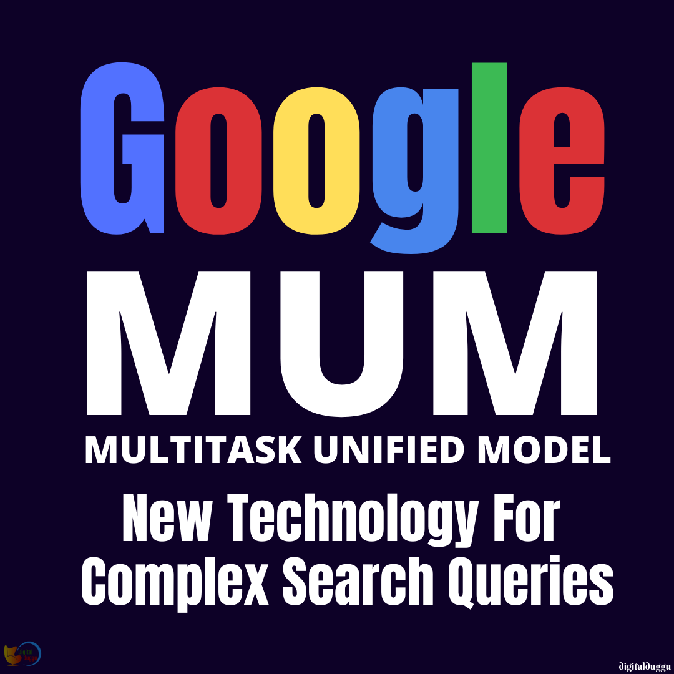

Google’s first application of [Multitask Unified Model](https://www.w3era.com/blog/) (MUM) in real-world search results is to get actual searches for vaccine information in all languages.

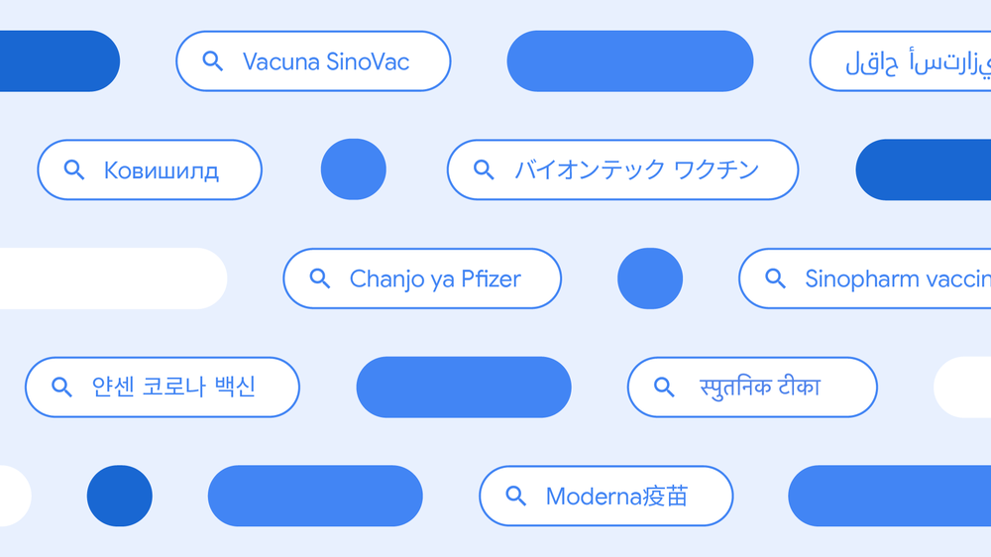

MUM stands for Multitask Unified Model. It is a modern technology produced by Google to solve complicated search queries. In real-world search results, MUM suggests doing it to understand inequalities of searches for COVID-19 vaccine information. The first information about MUM was initiated in May by Google and saying it was in the testing steps and would implement search results in the upcoming months and years.

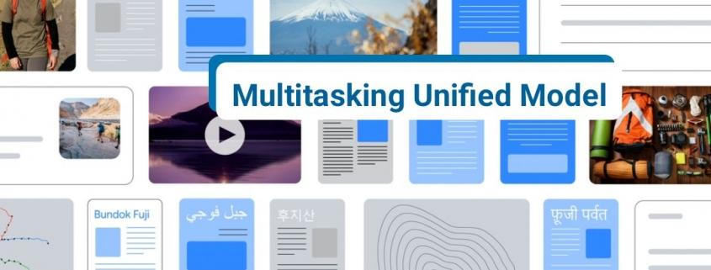

The company approves that MUM is now being used in search results to precisely identify over 800 keywords people use to search for vaccines and read the latest trustworthy information.

**Free To Consult with our Expert, Book an Appointment Now:** [**https://www.w3era.com/contact-us/**](https://www.w3era.com/contact-us/)

**“AstraZeneca, CoronaVac, Moderna, Pfizer, Sputnik, and other broadly distributed vaccines all have many different names all over the world — over 800, based on our analysis. People searching for information about the vaccines may look for “Coronavaccin Pfizer,” “mRNA-1273,” “CoVaccine” — the list goes on.”**

Google says that with MUM to know over 800 variations of vaccine names in more than 70 languages within seconds and without MUM, identifying all the vaccine names that people use to refer all over the world would have taken hundreds of human hours.

After verifying MUM’s judgments, Google implemented them to search results so that people could find timely, high-quality information about COVID-19 vaccines worldwide.

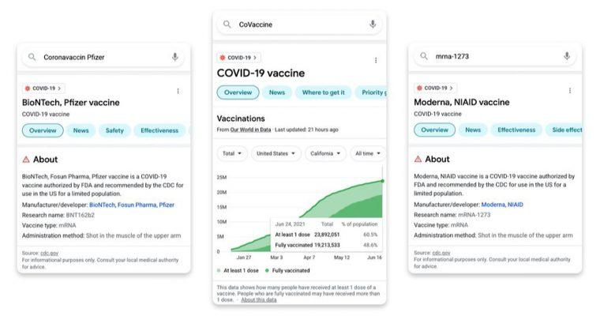

*Showing reliable information about COVID-19 vaccines in search.*

**“MUM was able to do a job that should take weeks in just seconds, thanks to its knowledge transfer skills. MUM can learn from and transfer knowledge across the 75+ languages it’s trained on.”**

## What is Next For MUM?

Vaccine search is the first and only approved application of MUM in search results so far. Google expects to proceed using MUM in ways that make search more valuable to people.

This may involve improving on services that are already available or using MUM to create new tools.

**“This first application of MUM helped us get critical information to users around the world in a timely manner, and we’re looking forward to the many ways in which MUM can make Search more useful to people in the future.**

**Our early testing indicates that not only will MUM be able to improve many aspects of our existing systems, but will also help us create completely new ways to search and explore information.”**

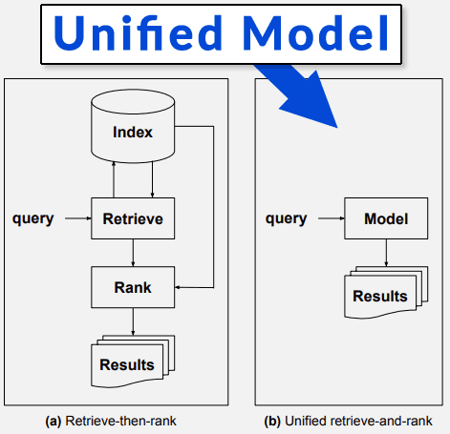

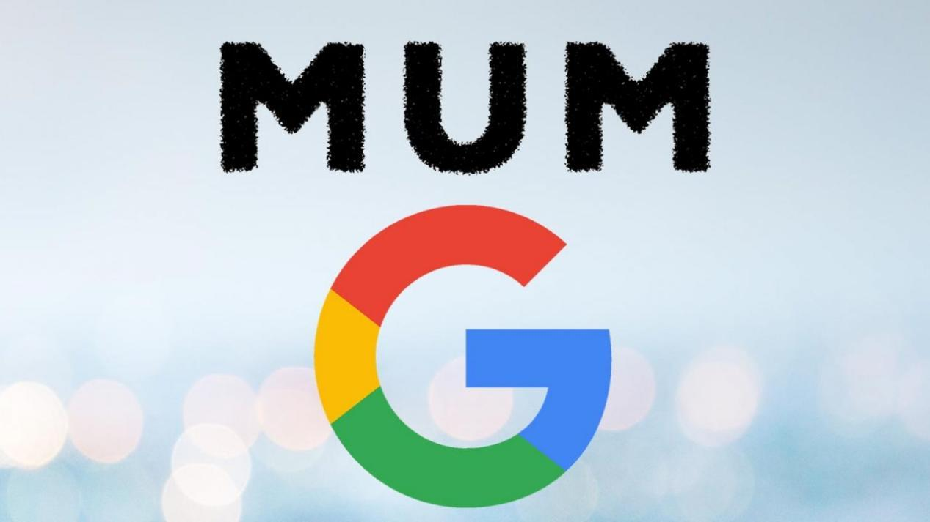

MUM is multi-modal, which signifies it can understand information from different compositions like [webpages](https://www.w3era.com/), pictures, and more, concurrently. MUM is an outstanding milestone toward a future where Google can understand all of the different forms people usually communicate and evaluate information.

**Vinita Choubisa**

**(Digital Marketing Executive)**